Press release · for immediate release
KAYA DAY 2026
The second annual celebration of KAYA, the king of seggae. From Mauritius to Réunion, opening with the RAS NININ FET KAYA concert.
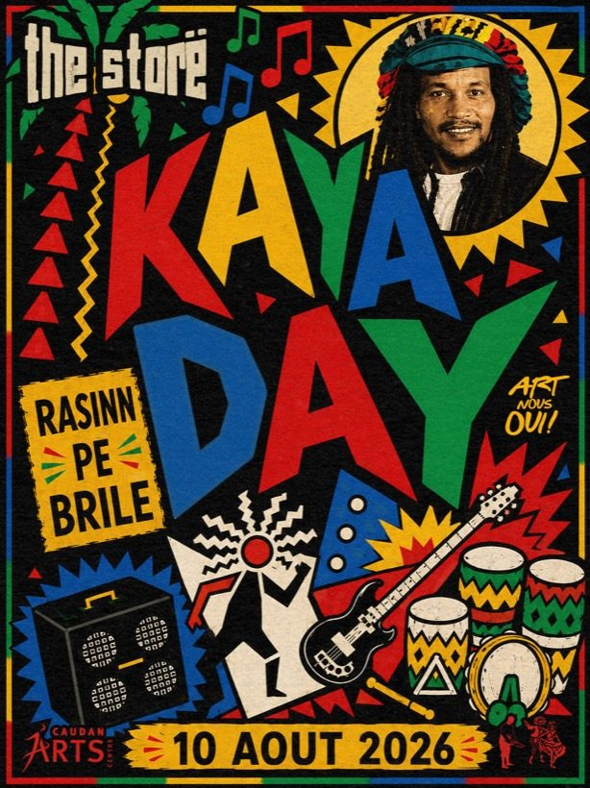
KAYA DAY 2026 · the storë, Caudan Arts Centre
Port-Louis, Mauritius · for immediate release
Come dive into KAYA's world: his archives, his music, his sound.
On 10 August, the day Joseph Réginald Topize was born, Mauritius and the wider Indian Ocean celebrate the man known as KAYA, the creator of seggae. KAYA DAY returns for its second year at the Caudan Arts Centre, led by the cultural label BABANI with the KAYA Estate. It is a memory day, with seggae playing all day, and it is open to all. This year the celebration opens with a concert, RAS NININ FET KAYA, the first official concert from the KAYA Estate, on 25 July. The idea is simple: to bring Mauritius to the world. KAYA belongs to the world, and KAYA DAY carries his story to an international stage.
Who was KAYA?
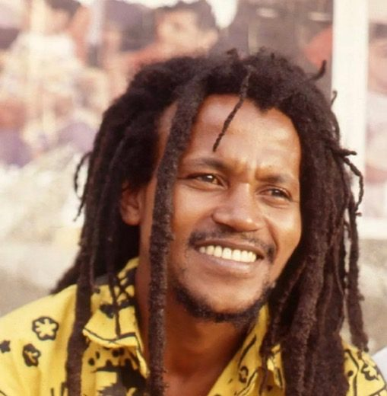
KAYA · Joseph Réginald Topize
In Mauritius, KAYA is a name spoken with the same reverence as Fela Kuti or Bob Marley. He was the island's musical conscience, la voix des mauriciens, the voice of Mauritians. A Rastafarian poet who rose from humble beginnings, his music carried a message of identity, unity and pride. His life was cut short in 1999, and he remains an enduring symbol of freedom and belonging, la voix de la liberté.
→ KAYA's full story on kaya.mu
What is seggae? The sound of an island
Seggae is the genre KAYA created. It is not a subgenre of reggae but a parallel evolution, a sound as unique to Mauritius as bossa nova is to Brazil. Born in the late 1980s, seggae is a powerful fusion of the militant soul of Jamaican roots reggae with the spiritual, triple-beat rhythm of the island's traditional sega. Sung in Mauritian Creole, it is the sound of an island, the raw, authentic voice of the Indian Ocean.
The roots of a legacy. The early sound of seggae first took shape when KAYA's talent was brought into the studio by producer Percy Yip Tong, who recorded his formative work through Cyper Produktion. These first sessions captured the raw energy that would define the genre's foundation.
→ seggae, the full story on kaya.mu/seggae
The art of seggae: the visuals of Henry Koombes
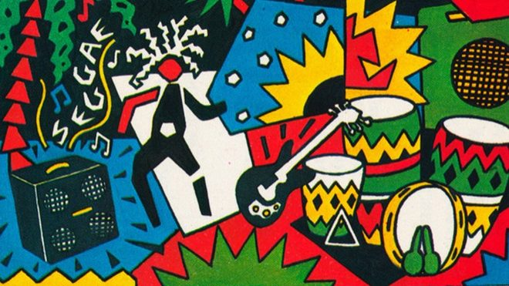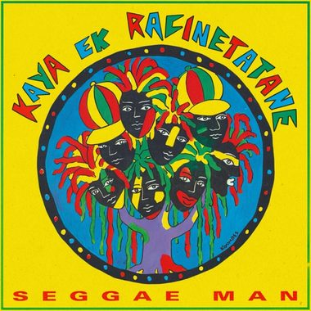
Henry Koombes · seggae cover art
Alongside the sound, seggae developed a powerful visual identity, largely shaped by one artist: Henry Koombes. A Mauritian artist, militant and passionate music lover in his own right, also known as a reggae and dub selecta, Koombes was a constant creative force who collaborated with KAYA across different eras. His vibrant cover art became synonymous with the movement, each cover adding a new chapter to the story. His work is a testament to the BABANI ethos of 50% music, 50% visuals, where cultural heritage must be seen as well as heard.
→ Henry Koombes' full body of work on kaya.mu/koombes
The path forward
For over 25 years, KAYA's legacy has been fragmented. The mission of KAYA DAY and the wider archival work is to heal that fragmentation. Acting in good faith with KAYA's family, BABANI works with one goal: to let KAYA shine. The world needs to hear this music and know this story.
→ inside the KAYA archives on kaya.mu/archives
The KAYA Estate

The KAYA Estate is the family body that safeguards KAYA's name, image, music and archives. Its purpose is to protect his legacy and to carry his work to the world with dignity and in good faith. KAYA DAY is led by the Estate, together with BABANI.
→ the KAYA Estate on kaya.mu/estate

KAYA DAY 2026: the programme
The 2026 celebration unfolds in two moments.
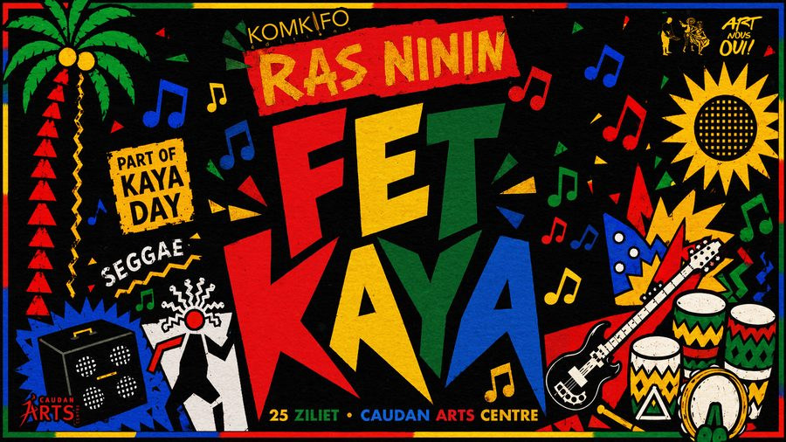
RAS NININ FET KAYA · 25 July 2026 · Caudan Arts Centre
RAS NININ FET KAYA, the concert. FET KAYA is the celebration, the first official concert from the KAYA Estate, carried by RAS NININ with the support of KOMKIFO. RAS NININ celebrates KAYA through songs from his repertoire, in a live, sincere reinterpretation carried by the energy of seggae. A collaboration between Mauritius and Réunion. Conceived as an audio and visual experience.
Saturday 25 July 2026 · from 18h00
Caudan Arts Centre, Port-Louis
Tickets: 600, 800 and 1,000 Rs
→ RAS NININ FET KAYA on kaya.mu/fetkaya
KAYA DAY, the memorial day. 10 August 2026, KAYA's birthday. A day of memory, given to listening to and promoting seggae, the music KAYA created, at the storë. Seggae plays all day, and his archives, photos, cassettes and stories keep his memory alive. Open to all.

→ the full programme on kaya.mu/day
ZAFAIR KAYA, the film. As part of KAYA DAY, an educational screening of the documentary ZAFAIR KAYA, directed by Michel Vuillermet, courtesy of Selven Naidu. Many still do not know KAYA's story, and the film helps new audiences discover the man and his music.
A growing archive. KAYA DAY is also a living archive that keeps growing. Each year adds more, more photos, recordings, objects and stories, gathered to celebrate KAYA on his day. There is always more to come.
Contribute to the archive. If you hold KAYA material, cassettes, records, photos, videos or stories, we invite you to share it. Every piece helps the archive grow. Write to archives@kaya.mu.
Play seggae on 10 August. We invite radio, press and venues to play seggae on 10 August in KAYA's memory. On request we can provide a KAYA and seggae playlist, or a DJ mix, for broadcast or features. Write to support@kaya.mu.
The venue
Nous sommes heureux de contribuer à la célébration de la mémoire et de l'héritage artistique de KAYA. En accueillant au Caudan Arts Centre KAYA DAY et RAS NININ FET KAYA, nous souhaitons participer au rayonnement de cette initiative portée par KAYA Estate et BABANI, tout en renforçant sa dimension régionale grâce à la collaboration avec l'Agence KOMKIFO de La Réunion, dans le cadre de ZILANZIL 2026.
We are glad to contribute to celebrating the memory and artistic legacy of KAYA. By hosting KAYA DAY and RAS NININ FET KAYA at the Caudan Arts Centre, we wish to take part in the reach of this initiative led by the KAYA Estate and BABANI, while strengthening its regional dimension through the collaboration with the KOMKIFO agency of Réunion, as part of ZILANZIL 2026.
Ashish Beesoondial theatre manager, Caudan Arts Centre
RAS NININ
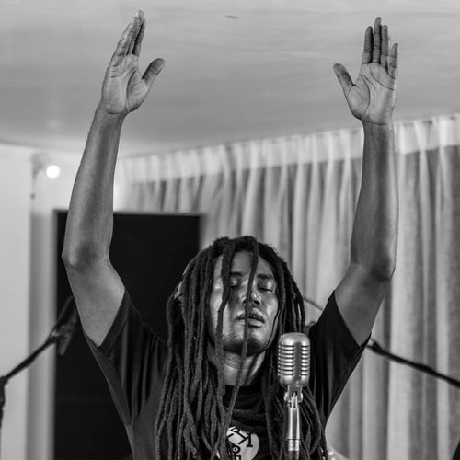
RAS NININ · press photo
A Mauritian artist, RAS NININ extends the spirit of seggae with consciousness, simplicity and depth. Since his first album Obzervé with the Kool Kreol Band, his songs observe society, everyday life, family and love. His journey has echoed beyond Mauritius: he has performed in Réunion, notably at IOMMa, and is signed to Red Island Records, a Réunion label.
→ RAS NININ on kaya.mu/ninin
The visual archives: key historical documents
Three video documents help tell the story.
▶ The story of seggae (Radio Nova, 2024) · In French. www.youtube.com/watch?v=6zfjVbXtob0
▶ The producer's account (Percy Yip Tong) · In French. youtu.be/7UwolMf5xg4
▶ Live concert archive (MBC, 1990s) www.youtube.com/watch?v=CvJt2bxAjIg
About BABANI
The name BABANI refers to the state of trance reached in a ceremony invoking ancestral spirits. In that spirit, BABANI acts as a collective focused on the transmission of the cultural heritage of the Indian Ocean islands. Founded by Avneesh Bacha, BABANI is the cultural initiative and record label from Bōucan Road Studios. Its mission is to restore and preserve the region's rich history through music, art and film. Operating on a 50% music, 50% visuals ethos and a principle of fair collaboration, BABANI is the handshake from the Indian Ocean to the world.
→ more on babani.mu
In brief
The storë. ë's record shop and listening space, home to vinyl, merch and archives. The KAYA DAY exhibition lives there.
The Caudan Arts Centre. A performing and visual arts venue at the Caudan Waterfront in Port-Louis, Mauritius, and the host of KAYA DAY 2026.
BABANI. The cultural label and initiative from Bōucan Road Studios, preserving the musical heritage of the Indian Ocean. It leads KAYA DAY with the KAYA Estate.
KRÉOL ART. A Réunion partner in music, vinyl and archives, working alongside BABANI on the region's heritage.
ë. The cultural ecosystem behind the project: label, studio, archive and design, bringing the music of Mauritius and the Indian Ocean to the world.
KOMKIFO. The Réunion agency hosting FET KAYA, bringing a regional Mauritius and Réunion dimension to the celebration.
Press and interviews: support@kaya.mu
Images and archives: archives@kaya.mu
Online: kaya.mu · Press kit: kaya.mu/press
Local and international press welcome.
Print and poster formats available on request.
Led by the KAYA Estate with BABANI · in partnership with KOMKIFO & Kréol Art (Réunion) · powered by ë
In partnership
